<https://mdelab2-core1.centralus.cloudapp.azure.com:8000/swagger/ui/index#!/Sessions/Sessions_AddSessionAsync>

This swagger page has the details of the endpoints for Metadact API 2.0

**STEP 1. POST_create new session id**

https://mdelab2-core1.centralus.cloudapp.azure.com:8000/api/v2/Sessions

**STEP 2. POST_callORIGINALendpoint_setDocument_for_cleaning**

https://mdelab2-core1.centralus.cloudapp.azure.com:8000/api/v2/Sessions/82867f07-0f3d-489e-9955-d66e952c4009/Original

**STEP 3. GET_get_session_State_processing_processed**

https://mdelab2-core1.centralus.cloudapp.azure.com:8000/api/v2.0/sessions/82867f07-0f3d-489e-9955-d66e952c4009

**STEP 4. GET-Cleaned_Documents**

https://mdelab2-core1.centralus.cloudapp.azure.com:8000/api/v2/Sessions/82867f07-0f3d-489e-9955-d66e952c4009/Cleaned

**STEP 5 GET_getReport_of the session**

<https://mdelab2-core1.centralus.cloudapp.azure.com:8000/api/v2.0/sessions/82867f07-0f3d-489e-9955-d66e952c4009/Report>

<https://mdelab2-core1.centralus.cloudapp.azure.com:8000/swagger/ui/index#!/Sessions/Sessions_AddSessionAsync>

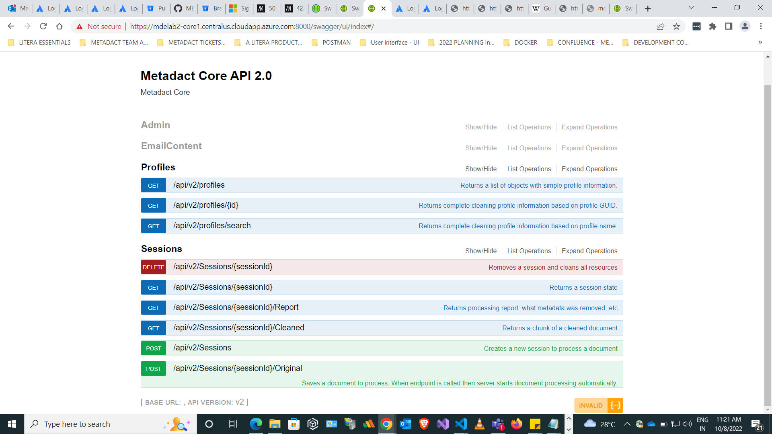

***STEP 1. POST_create new session id - >>> USING POST***

<https://mdelab2-core1.centralus.cloudapp.azure.com:8000/api/v2/Sessions>

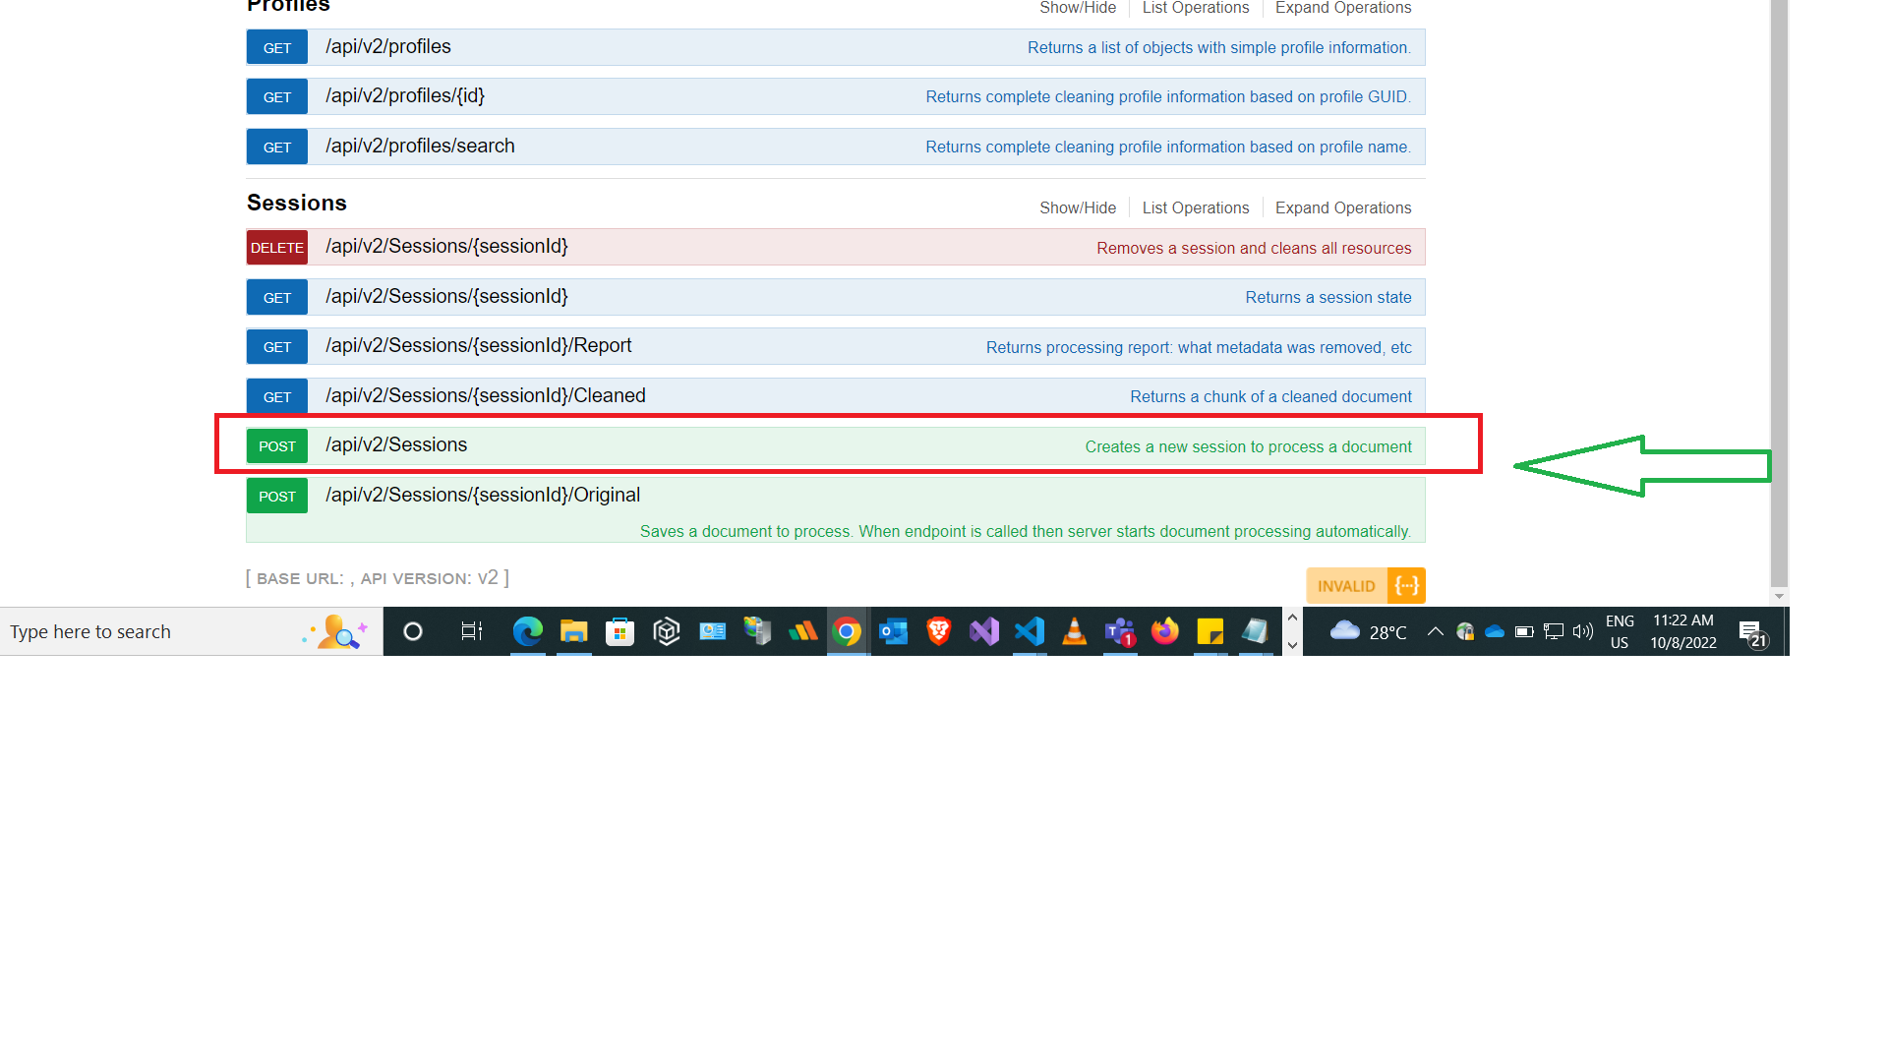

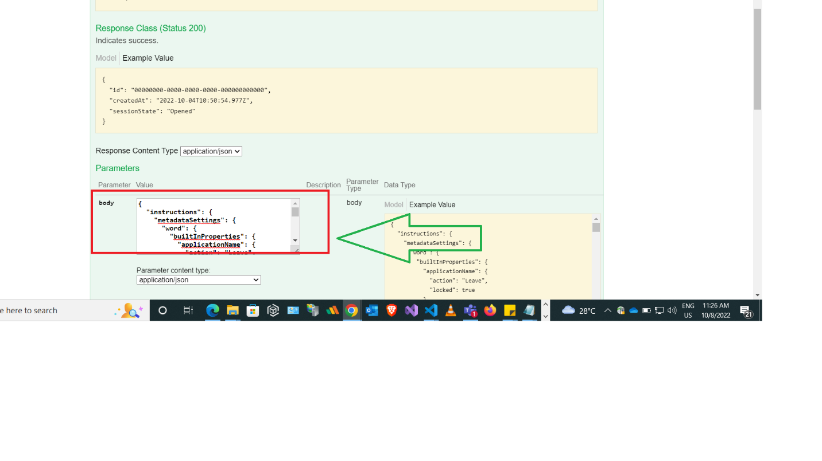



Copy the body and paste in the

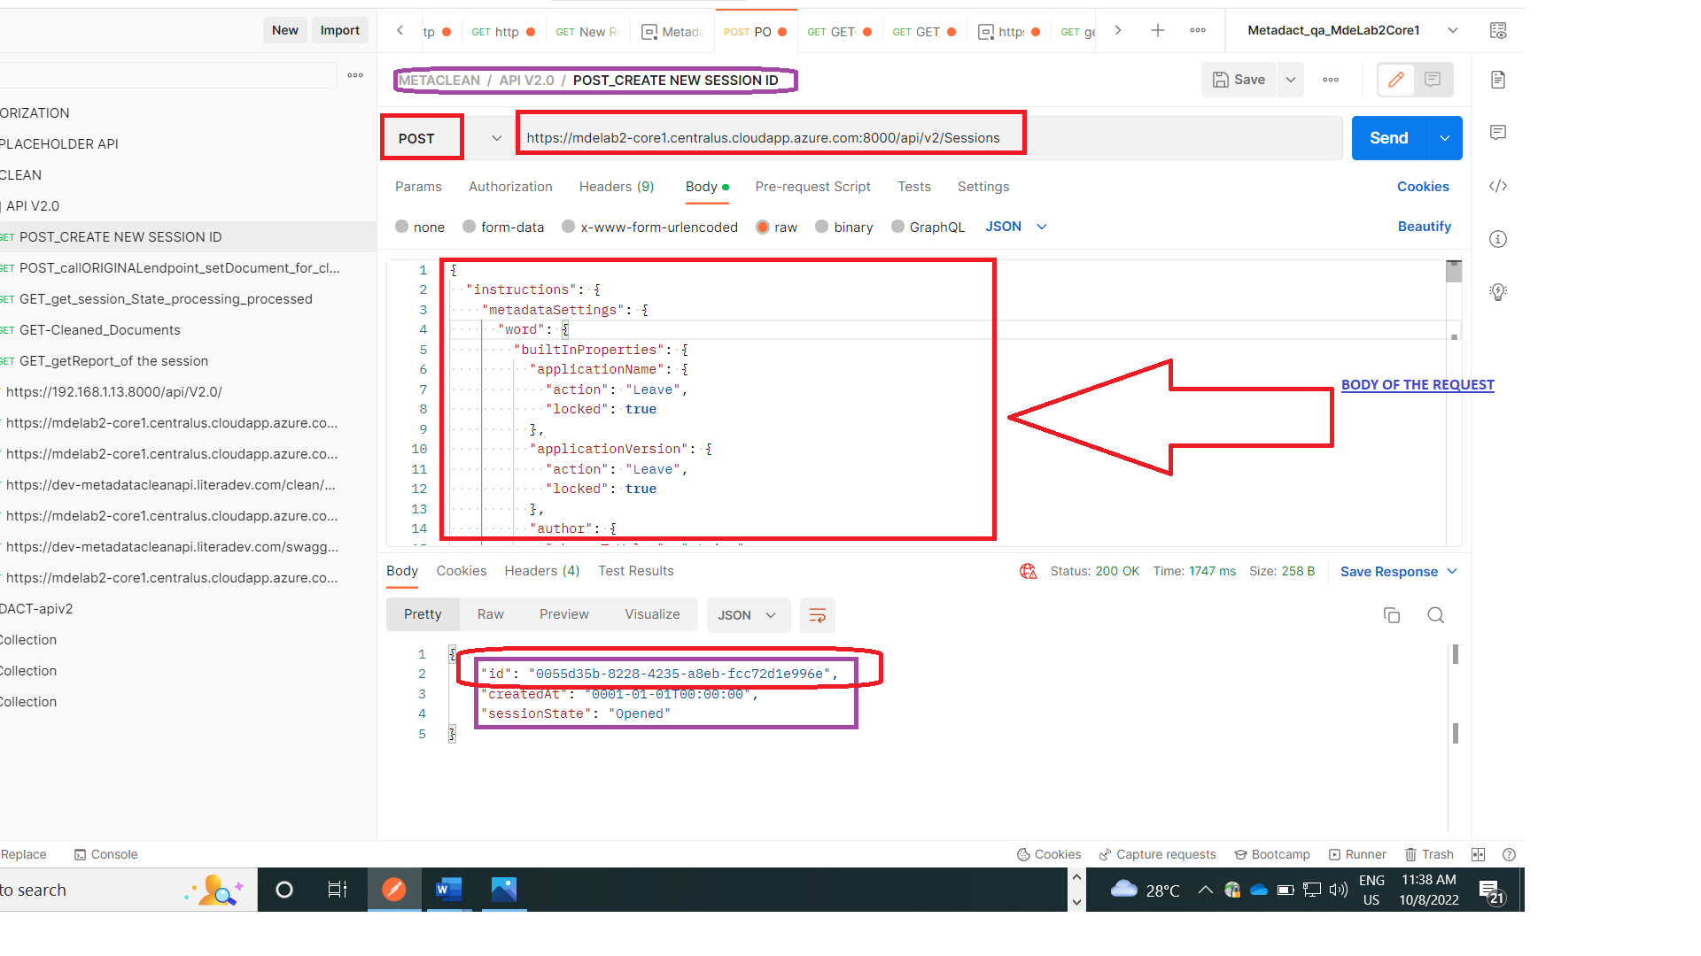

Method : post

URL : <https://mdelab2-core1.centralus.cloudapp.azure.com:8000/api/v2/Sessions>

Now, on clicking send button, a new session is created.

And in the Response body

We can see the following

{

    "id": "0055d35b-8228-4235-a8eb-fcc72d1e996e",

    "createdAt": "0001-01-01T00:00:00",

    "sessionState": "Opened"

}

***STEP 2: POST_callORIGINALendpoint_setDocument_for_cleaning***

NEWLY CREATED SESSION ID: “0055d35b-8228-4235-a8eb-fcc72d1e996e”

<https://mdelab2-core1.centralus.cloudapp.azure.com:8000/api/v2/Sessions/SESSION> ID/Original

<https://mdelab2-core1.centralus.cloudapp.azure.com:8000/api/v2/Sessions/>0055d35b-8228-4235-a8eb-fcc72d1e996e/Original

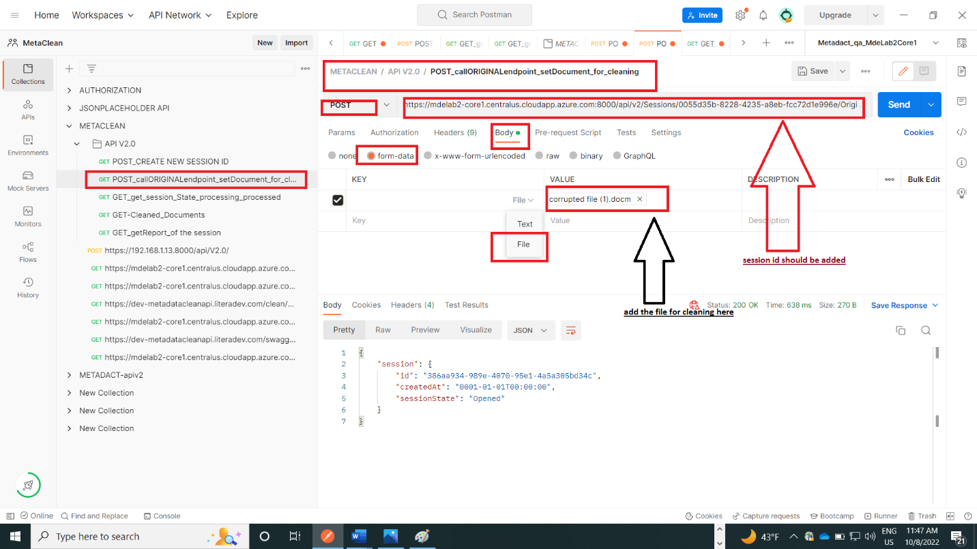

After clicking the send button,

The status is 200 ok

And in the response body the following will come

{

    "session": {

        "id": "267d7ec9-7d57-4b5c-b52b-d57563e0e43d",

        "createdAt": "0001-01-01T00:00:00",

        "sessionState": "Opened"

    }

}

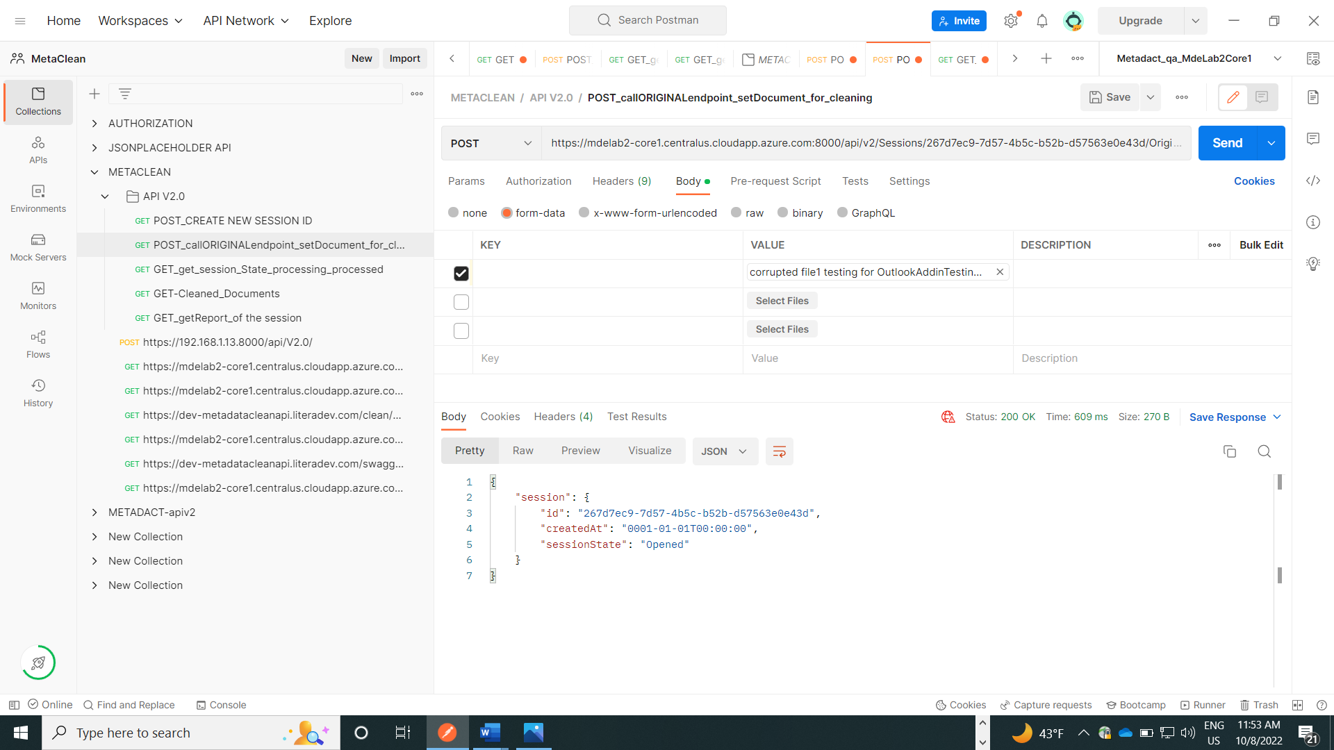

***Step 3: to GET the session state***

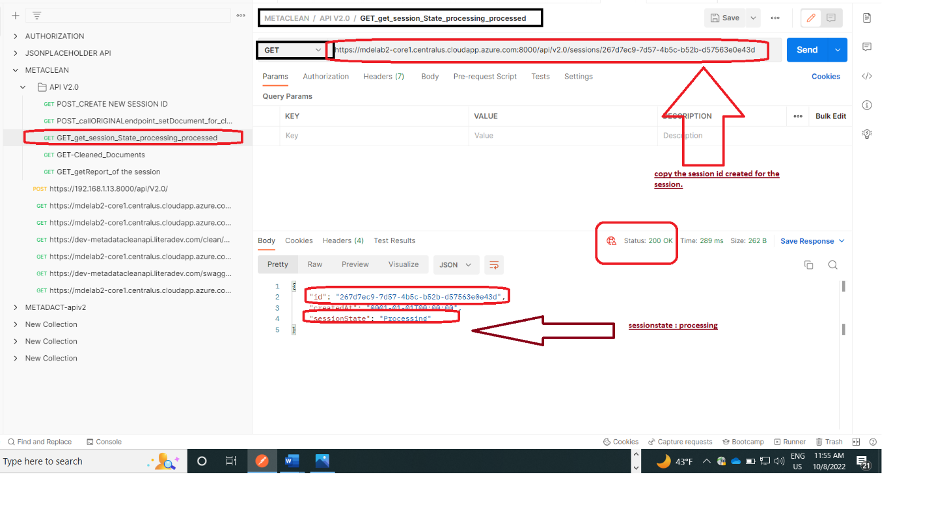

SESSIONSTATE: PROCESSED

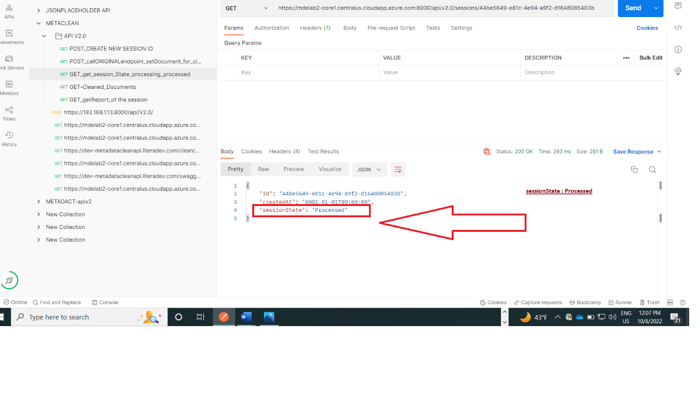

***STEP 4: GET cleaned documents***

URL:::: https://mdelab2-core1.centralus.cloudapp.azure.com:8000/api/v2/Sessions/44be5649-e81c-4e94-a9f2-d1648085403b/Cleaned

IF THE SESSION STATE IS : PROCESSING, then the following screenshot shows the output

{

    "message": "Session has Processing status."

}

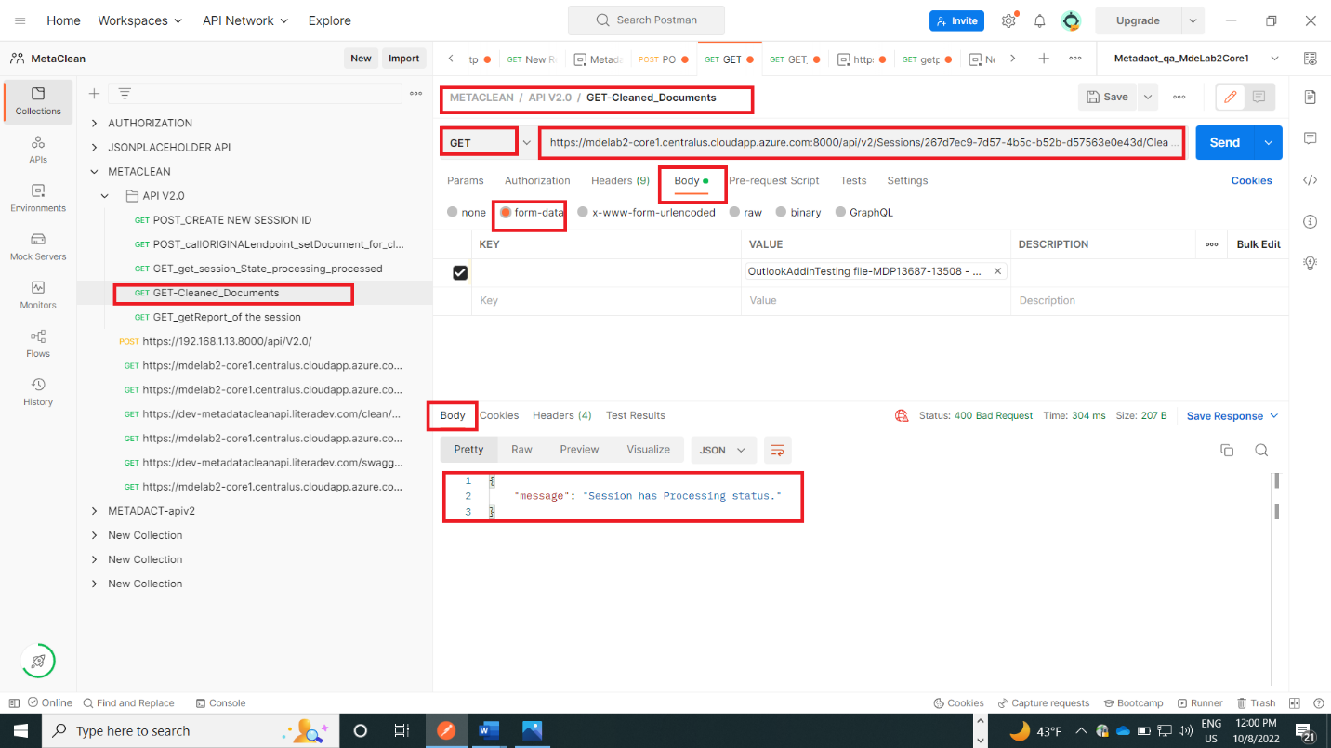

If the session is processed, the following screenshot output will come

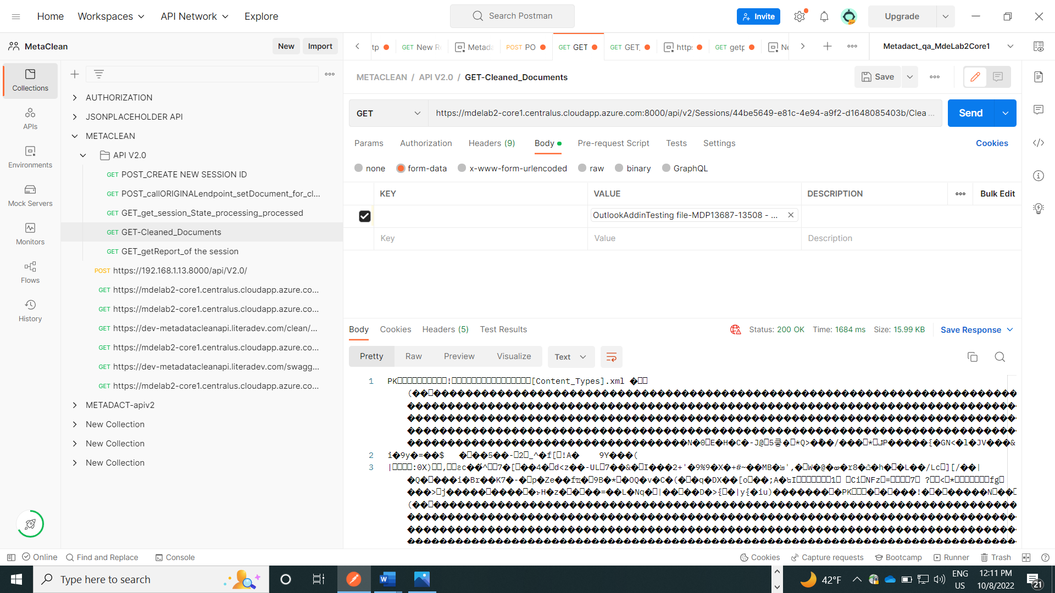

The response body will contain the cleaned document and now save the file

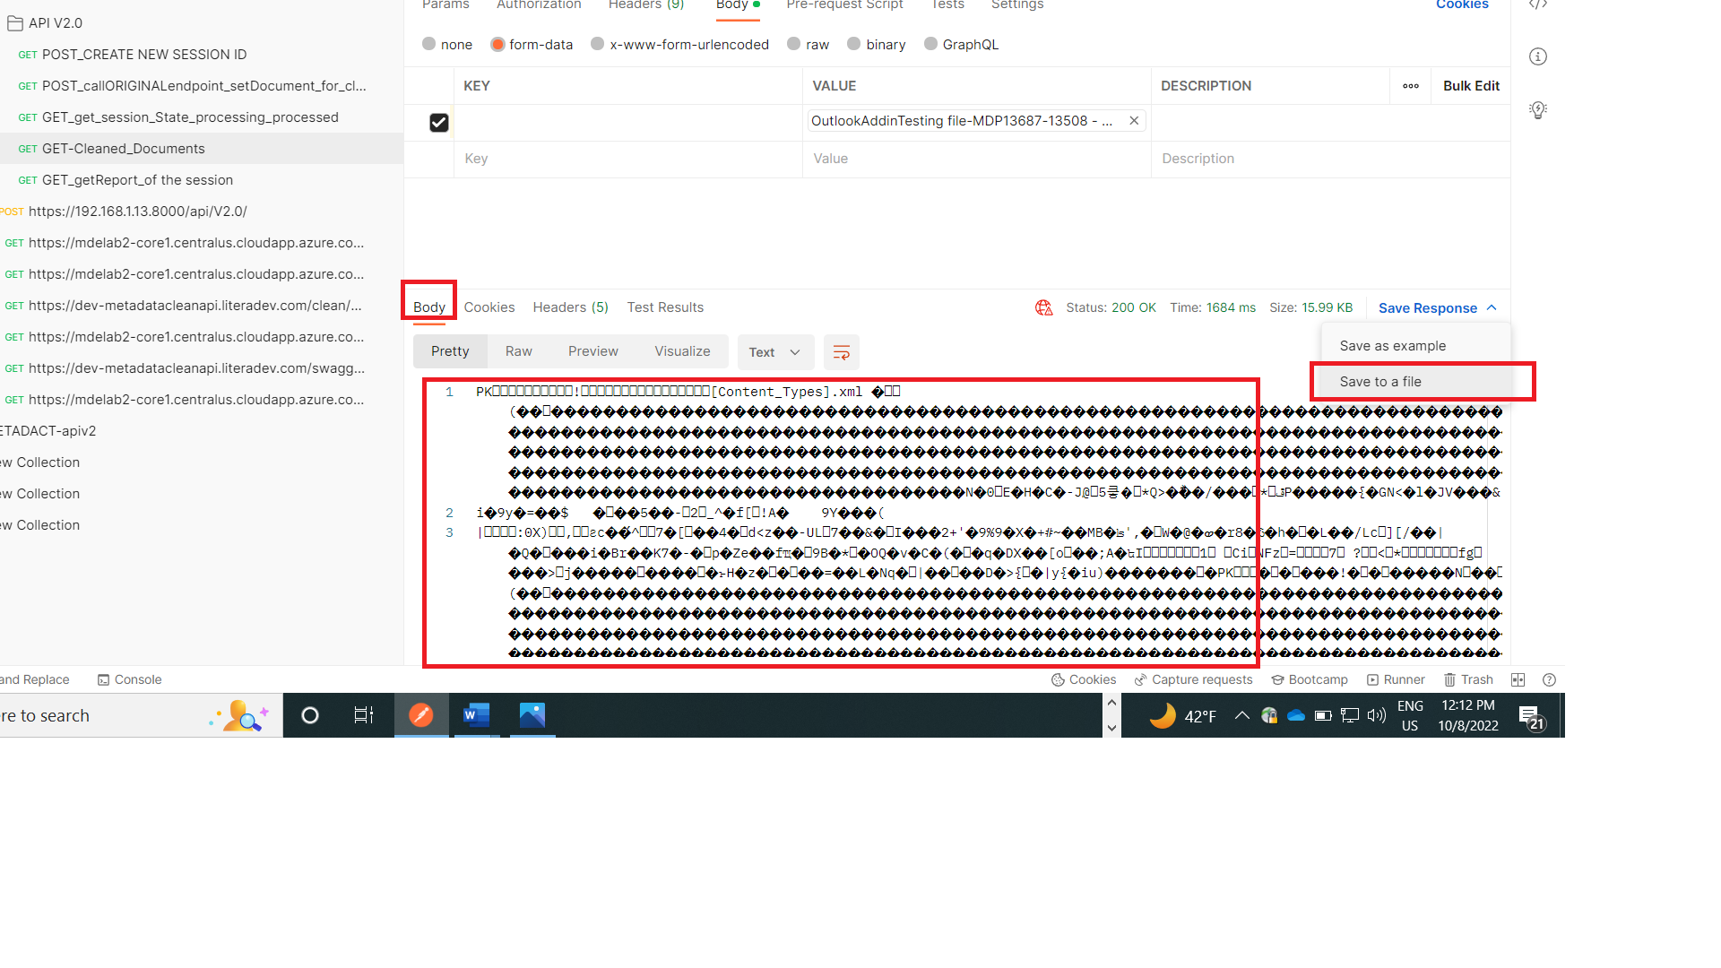

***5. GET_getReport_of the session***

If the sessionState: processing and if we try to get the report, null value is returned

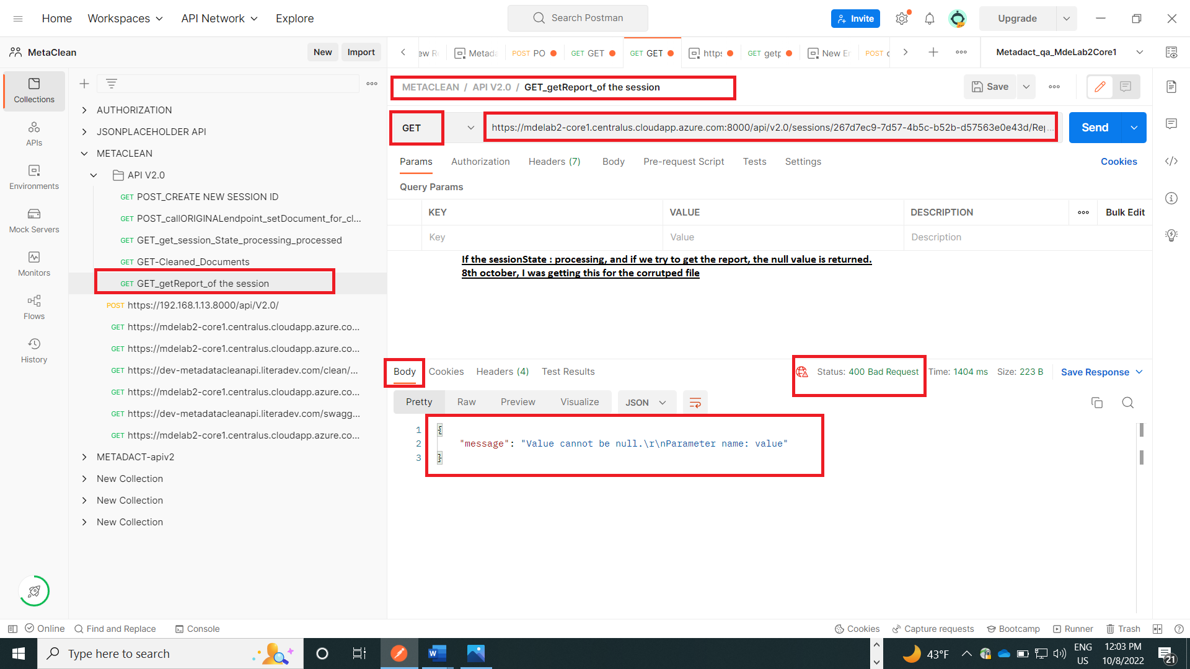

If the sessionState: processed and if we try to get the report, some value is returned

